Data Modeling – Quick Reference Notes
🔹 Definition
- Data Modeling = The process of creating a blueprint for how data is stored, connected, and retrieved in a system.
- It defines the architecture, strategy, and techniques used to structure data.
- For data engineers, modeling is more complex than for analysts/DBAs because it must ensure:
  - Scalability (future growth)
  - Performance (efficient queries)
  - Reporting readiness (usable by BI/analytics teams)
- It applies throughout the data journey (ingestion → transformation → storage → consumption), not just at the final stage.

🎯 Importance & Benefits
- Clarity & Usability → Makes data understandable for analysts, scientists, BI developers.
- Performance → Optimized queries, reduced latency.
- Scalability → Supports future expansion without redesign.
- Governance & Auditability → Ensures lineage, compliance, and trust in data.
- Collaboration → Provides a shared language between engineers, analysts, and business stakeholders.

🏗️ Types of Data Models
Every model evolves through three layers:
- Conceptual Model (Business View)
  - High-level overview: entities + relationships.
  - Example: Customer → places → Order → contains → Product.
  - Audience: Business stakeholders, analysts.
- Logical Model (Technical Blueprint)
  - Defines relationships, primary keys, foreign keys, cardinality.
  - Independent of DBMS (no data types yet).
  - Example: CustomerID (PK), OrderID (FK), ProductID (FK).
- Physical Model (Implementation)
  - Actual database design: tables, columns, data types, indexes, partitions, triggers.
  - Example: CustomerID INT, Name VARCHAR(100), OrderDate DATE, Index on OrderDate.

⚖️ Data Modeling Approaches
Feature | OLTP (Transactional) | OLAP (Analytical)
Purpose | Fast, reliable transaction handling | Complex queries & analysis
Priority | Efficient writes | Efficient reads
Core Approach | Normalization → reduce redundancy | Dimensional Modeling (Star/Snowflake schema)
Structure | Many small tables, normalized | Fact + Dimension tables
Role | Built by DBAs | Built by Data Engineers
Example | Banking system (debit/credit transactions) | Sales dashboard (Revenue by Region, Product, Time)

📊 Dimensional Data Modeling (OLAP Focus)
- Facts → Numerical, measurable data (e.g., SalesAmount, Quantity).
- Dimensions → Contextual attributes (e.g., Date, Region, Product).
- Schemas:
  - Star Schema → Central fact table + dimension tables.
  - Snowflake Schema → Dimensions further normalized.
- Layers in Modern Data Engineering:
  - Bronze (Raw) → Ingested data, minimal transformation.
  - Silver (Enriched) → Cleaned, standardized, joined.
  - Gold (Curated) → Business-ready, aggregated, modeled for reporting.

🛠️ Best Practices for Data Engineers
- Design for Scalability → Anticipate growth in data volume & complexity.
- Balance Normalization vs. Denormalization → Normalize for OLTP, denormalize for OLAP.
- Use Surrogate Keys → Avoid natural keys for flexibility.
- Indexing & Partitioning → Improve query speed and manage large datasets.
- Document Lineage → Track transformations for auditability.
- Metadata-Driven Design → Automate schema evolution & pipeline orchestration.
- Layered Architecture → Bronze → Silver → Gold ensures clean progression.

🧠 Quick Interview Pointers
- Q: Why is data modeling important for data engineers?
A: It ensures scalability, performance, and usability across the data lifecycle.
- Q: Difference between OLTP vs OLAP modeling?
A: OLTP → normalized, write-optimized; OLAP → dimensional, read-optimized.
- Q: What are fact and dimension tables?
A: Facts = measurable values; Dimensions = descriptive context.
- Q: Why use layered (Bronze/Silver/Gold) architecture?
A: To progressively refine raw data into curated, business-ready datasets.
Got it, Ganapathi 👍 — let’s make normalization super clear and step-by-step with definition + before/after tables so you can see exactly how data changes at each stage. Think of it like cleaning and organizing a messy cupboard: each step removes a different kind of mess.

Normalization Explained Clearly

1️⃣ First Normal Form (1NF) – Atomic Values
Definition:
- Break down repeating groups.
- Each column must hold a single, indivisible value.
Before (Not in 1NF)
| CustomerID | Name | PhoneNumbers | |------------|------|----------------| | 101 | Ravi | 98765, 87654 |
After (1NF)
| CustomerID | Name | PhoneNumber | |------------|------|-------------| | 101 | Ravi | 98765 | | 101 | Ravi | 87654 |
👉 Problem solved: No multiple values in one cell.

2️⃣ Second Normal Form (2NF) – No Partial Dependency
Definition:
- Must be in 1NF.
- Non-key attributes must depend on the whole primary key, not just part of it.
Before (Not in 2NF)
| OrderID | ProductID | ProductName | Quantity | |---------|-----------|-------------|----------| | 5001 | P01 | Laptop | 2 |
👉 Composite key = (OrderID, ProductID). But ProductName depends only on ProductID.
After (2NF)
OrderDetails
| OrderID | ProductID | Quantity | |---------|-----------|----------| | 5001 | P01 | 2 |
Products
| ProductID | ProductName | |-----------|-------------| | P01 | Laptop |

3️⃣ Third Normal Form (3NF) – No Transitive Dependency
Definition:
- Must be in 2NF.
- Non-key attributes should not depend on other non-key attributes.
Before (Not in 3NF)
| CustomerID | CustomerName | City | State | |------------|--------------|------------|---------| | 101 | Ravi | Vijayawada | Andhra |
👉 State depends on City, not directly on CustomerID.
After (3NF)
Customers
| CustomerID | CustomerName | CityID | |------------|--------------|--------| | 101 | Ravi | C01 |
Cities
| CityID | City | State | |--------|------------|---------| | C01 | Vijayawada | Andhra |

4️⃣ Boyce-Codd Normal Form (BCNF) – Stronger 3NF
Definition:
- Every determinant must be a candidate key.
- Fixes anomalies left in 3NF.
Before (Not in BCNF)
| Professor | Subject | |-----------|---------| | A | DBMS | | B | DBMS |
👉 Here, Subject → Professor, but Subject is not a candidate key.
After (BCNF)
Professors
| Professor | SubjectID | |-----------|-----------| | A | S01 | | B | S02 |
Subjects
| SubjectID | Subject | |-----------|-----------| | S01 | DBMS | | S02 | Networks |

5️⃣ Fourth Normal Form (4NF) – No Multi-Valued Dependency
Definition:
- Must be in BCNF.
- Remove attributes that can have multiple independent values.
Before (Not in 4NF)
| StudentID | Skill | Hobby | |-----------|---------|---------| | 201 | Python | Cricket | | 201 | SQL | Music |
👉 Skills and hobbies are independent multi-valued attributes.
After (4NF)
StudentSkills
| StudentID | Skill | |-----------|---------| | 201 | Python | | 201 | SQL |
StudentHobbies
| StudentID | Hobby | |-----------|---------| | 201 | Cricket | | 201 | Music |

6️⃣ Fifth Normal Form (5NF) – No Join Dependency
Definition:
- Must be in 4NF.
- Break down complex many-to-many relationships so no unnecessary joins are needed.
Example (Simplified)
Supplier–Product
| SupplierID | ProductID | |------------|-----------| | S01 | P01 |
Product–Customer
| ProductID | CustomerID | |-----------|------------| | P01 | C01 |
Supplier–Customer
| SupplierID | CustomerID | |------------|------------| | S01 | C01 |

7️⃣ Sixth Normal Form (6NF) – Temporal Data
Definition:
- Deals with time-variant attributes.
- Rare, used in advanced data warehouses.
Example
EmployeeSalaryHistory
| EmployeeID | Salary | EffectiveFrom | EffectiveTo | |------------|--------|---------------|-------------| | E01 | 50000 | 2021-01-01 | 2022-01-01 | | E01 | 60000 | 2022-01-02 | 2023-01-01 |

✅ Shortcut to remember:
- 1NF → Atomic values
- 2NF → No partial dependency
- 3NF → No transitive dependency
- BCNF → Every determinant is a candidate key
- 4NF → No multi-valued dependency
- 5NF → No join dependency
- 6NF → Temporal data

What is ETL?

An ETL pipeline is a data workflow that extracts raw data from sources, transforms it into a usable format, and loads it into a target system such as a database or data warehouse. It ensures data is clean, consistent, and ready for analysis.

🔎 Detailed Explanation
- Extract (E):
  - Pulls raw data from multiple sources such as databases, APIs, applications, or files.
  - Example: Reading customer records from CRM systems and transaction logs from e-commerce platforms.
- Transform (T):
  - Cleans, validates, and reshapes the data to meet business or technical requirements.
  - Common transformations include:
    - Removing duplicates
    - Standardizing formats (e.g., dates, currencies)
    - Aggregating metrics (e.g., sales totals per region)
    - Applying business rules (e.g., mapping product codes to categories)
- Load (L):
  - Places the transformed data into a destination system such as:
    - A data warehouse for analytics
    - A database for operational use
    - A data lake for large-scale storage

⚙️ Real-World Example
Imagine an e-commerce company:
- Extract: Order details from the website, customer info from CRM, and payment records from a bank API.
- Transform: Standardize customer names, convert currencies, and calculate total revenue per region.
- Load: Store the cleaned data in a cloud data warehouse (e.g., Azure Synapse or Snowflake) for dashboards and reporting.

🧩 ETL vs. ELT
- ETL (Extract → Transform → Load): Transformation happens before loading into the target system.
- ELT (Extract → Load → Transform): Data is loaded first, then transformed inside the warehouse using its compute power.

ETL Layers:
🔄 ETL Layer Breakdown from the Diagram
1. SRC (Source Layer)
- Represents the origin of data (e.g., operational databases, APIs, flat files).
- Data is extracted incrementally — only new or changed records are pulled.
- Example: Records 1, 2, 3 are extracted.
2. Stage Layer
- A temporary landing zone for raw or semi-processed data.
- Supports incremental load and stores data either as:
  - Transient: Short-lived, used for quick processing.
  - Persistent: Stored longer for audit, recovery, or reprocessing.
- In the image, data 1, 2, 3 is staged before transformation.
3. Transform Layer
- Applies business logic and data cleaning.
- Uses Upsert operations (update existing records or insert new ones).
- Example:
- Input: 1, 2, 3
- Output: 1 01, 2 01, 3 01 — where 01 might represent versioning, status, or enriched values.
4. Serve (Model) Layer
- Final destination for transformed, trusted data.
- Often structured for analytics (e.g., star schema, dimensional models).
- Used by BI tools, dashboards, or downstream apps.
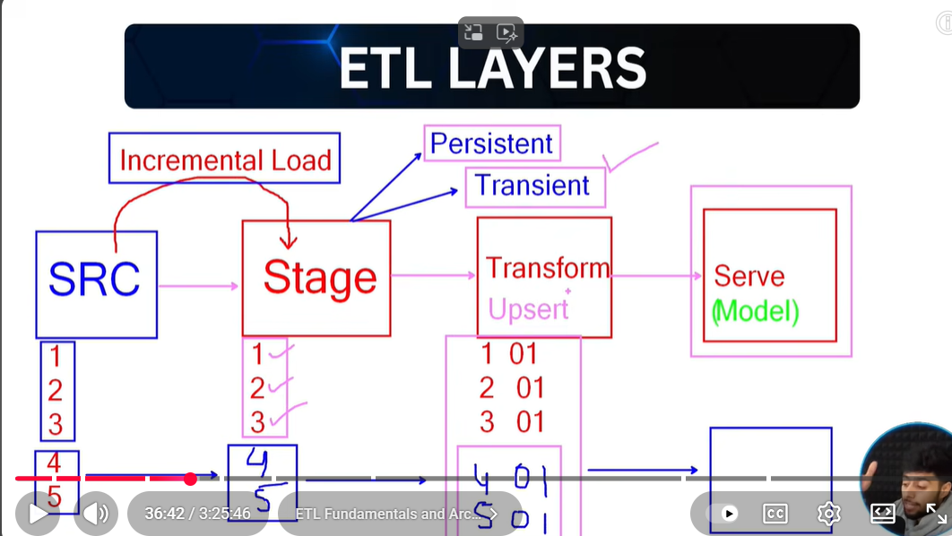

Medallion architecture:

📊 Understanding ETL Layers: Foundation for Scalable Data Modeling
ETL layers are foundational components in any data engineering workflow. They define how data is ingested, refined, and modeled across its journey from raw source systems to analytical destinations. Mastering these layers is essential for designing robust, scalable, and auditable data pipelines.
An ETL pipeline represents the structured flow of data from point A (source) to point B (destination)—typically an OLAP-based dimensional model. Each layer plays a distinct role in shaping the data, and understanding them is critical for implementing effective data modeling strategies.

🧱 Core ETL Layers and Their Architectural Equivalents
1. Staging Layer
Also known as: Raw Layer / Bronze Zone
This is the initial landing zone where data is ingested from source systems. It acts as a buffer between raw inputs and transformation logic.
- Purpose: Capture an unaltered replica of source data. No transformations are applied.
- Modern Terminology:
  - Raw Layer in general cloud architecture
  - Bronze Zone in Medallion architecture
- Staging Strategies:
  - Persistent Staging: Retains historical data; new records are appended.
  - Transient Staging: Replaces data on each load; ideal for managing incremental loads and simplifying downstream logic.

2. Transformation Layer
Also known as: Enriched Layer / Silver Zone
This layer is responsible for cleansing, enriching, and reshaping data to meet analytical and business requirements.
- Purpose: Apply business logic, handle nulls, deduplicate, standardize formats, and derive new attributes.
- Best Practice: Retain all enriched data to ensure traceability and auditability.
- Modern Terminology:
  - Enriched Layer in general cloud architecture
  - Silver Zone in Medallion architecture
- Key Concept:
  - Use Upsert (Merge) logic to ensure new records are inserted and existing ones are updated—critical for maintaining data integrity.
3. Serving Layer
Also known as: Curated Layer / Gold Zone
This is the final layer where data is modeled and exposed for consumption by BI tools, analysts, and stakeholders.
- Purpose: Deliver clean, structured, and query-optimized datasets.
- Data Modeling Fit:
  - Ideal for implementing OLAP dimensional models—fact and dimension tables derived from enriched data.
- Modern Terminology:
  - Curated Layer in general cloud architecture
  - Gold Zone in Medallion architecture

🔁 Data Flow Summary
As data moves through the ETL layers:
- It is ingested in raw form (Bronze),
- transformed with business logic (Silver),
- and modeled for analytics (Gold).
Star schema is a simple, denormalized design with a central fact table linked directly to dimension tables, while snowflake schema is a normalized design where dimensions are split into multiple related tables. Both are widely used in data warehousing, including platforms like Snowflake, but they serve different purposes depending on query performance and storage efficiency.

🌟 Star Schema
- Structure: Central fact table (measures like sales, revenue) connected to dimension tables (attributes like customer, product, time).
- Advantages:
  - Simple design, easy to understand.
  - Faster query performance due to fewer joins.
  - Ideal for OLAP and BI tools.
- Use Case: Best when query speed and simplicity are more important than storage optimization.

❄️ Snowflake Schema
- Structure: Similar to star schema but dimension tables are normalized into multiple related tables.
  - Example: A "Customer" dimension may split into Customer → Address → Region tables.
- Advantages:
  - Reduces data redundancy.
  - Saves storage space.
  - Better for complex hierarchies.
- Disadvantages:
  - More joins required → slower queries.
  - More complex to design and maintain.
- Use Case: Best when storage efficiency and normalized design are priorities.

📊 Visual Comparison
Here’s a diagram showing the difference between Star Schema vs Snowflake Schema:

⚖️ Choosing Between Them
- Star Schema:
  - Faster queries, simpler design.
  - Preferred for reporting and dashboards.
- Snowflake Schema:
  - Normalized, less redundancy.
  - Preferred for large, complex datasets with hierarchical dimensions.

Sources: GeeksforGeeks – Difference between Star and Snowflake Schema, DataCamp – Star vs Snowflake Schema, SoftwareTestingHelp – Schema Types in Data Warehouse
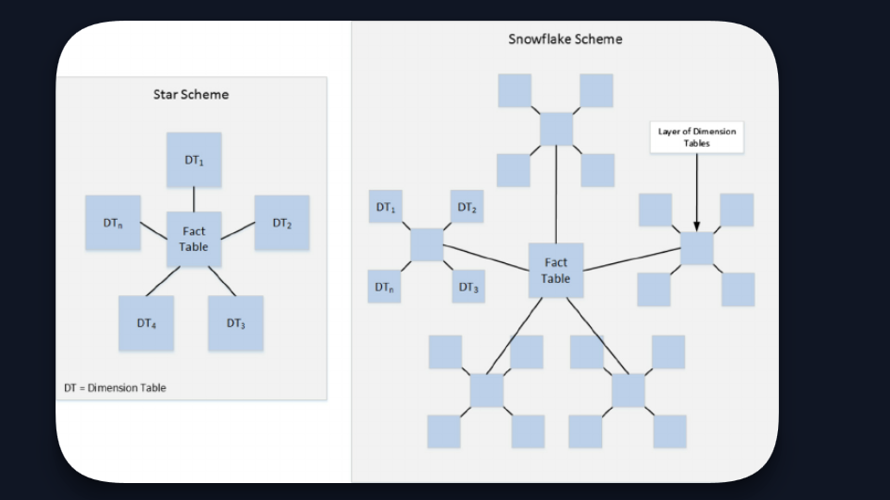

Fact Table:
A fact table is a central table in a data warehouse schema (usually in a star or snowflake schema) that stores quantitative data for analysis. It contains measurable facts (numeric values) about business processes and links to dimension tables that provide descriptive context.
Key Characteristics of a Fact Table
- Contains numeric measures (e.g., sales amount, quantity, revenue).
- Granularity: The level of detail (e.g., daily sales vs. monthly sales).
- Foreign keys: Connects to dimension tables (e.g., Date, Product, Customer).
- Large in size: Because it stores transactional or aggregated data.

Types of Fact Tables
There are mainly three types:

1. Transactional Fact Table
- Stores data at the lowest level of granularity (each transaction or event).
- Example: Each sales transaction in a retail store.
- Columns: Transaction_ID, Date_Key, Product_Key, Customer_Key, Sales_Amount.

2. Periodic Snapshot Fact Table
- Captures data at regular intervals (daily, monthly, quarterly).
- Used for performance tracking over time.
- Example: Daily account balances in banking.
- Columns: Date_Key, Account_Key, Balance.

3. Accumulating Snapshot Fact Table
- Tracks the lifecycle of a process (start to finish).
- Example: Order fulfillment process (order placed → shipped → delivered).
- Columns: Order_ID, Order_Date, Ship_Date, Delivery_Date.

✅ Bonus Types (sometimes considered subtypes):
Factless Fact Table
Contains only foreign keys, no numeric measures (used for tracking events or coverage).

Aggregate Fact Table
Stores pre-aggregated data for faster queries.

Dimensional Table:
A dimension table is a key component of a data warehouse schema that provides descriptive attributes (context) for the facts stored in a fact table. It answers the “who, what, where, when, why” questions about the business process.

✅ What is a Dimension Table?
- Stores textual or categorical data (descriptions, labels).
- Contains attributes that describe dimensions of facts (e.g., Product Name, Customer Name, Region).
- Usually has a primary key that links to the foreign key in the fact table.
- Typically smaller in size compared to fact tables.

Types of Dimension Tables (with Examples)

1. Conformed Dimension
- Shared across multiple fact tables or data marts.
- Example: Date Dimension used in both Sales and Inventory fact tables.
- Columns: Date_Key, Day, Month, Year.

2. Role-Playing Dimension
- Same dimension used for different roles in a fact table.
- Example: Date Dimension used as Order Date, Ship Date, Delivery Date.
- Columns: Date_Key, Day, Month, Year.

3. Slowly Changing Dimension (SCD)
- Handles changes in attribute values over time.
- Types:
  - Type 1: Overwrite old data (e.g., Customer address updated).
  - Type 2: Keep history by adding new rows (e.g., Customer moved to new city).
  - Type 3: Keep limited history using additional columns.
- Example: Customer Dimension with address changes.

4. Junk Dimension
- Combines miscellaneous attributes (flags, indicators) into one table.
- Example: Promotion Flags, Discount Indicators.

🗂️ What is a Junk Dimension?
- A junk dimension is used to store miscellaneous, low-cardinality attributes (often flags, indicators, or codes) that don’t belong in fact tables or other dimensions.
- Instead of cluttering the fact table with many small attributes, we combine them into one dimension.
- Common in ETL design when dealing with status flags, yes/no indicators, or small descriptive codes.

📊 Example: Order Flags Junk Dimension
JunkDimKey | OrderPriority | IsGiftWrap | HasDiscount | PaymentType | FraudCheckFlag
1 | High | Y | N | Credit Card | Pass
2 | High | N | Y | Debit Card | Pass
3 | Low | N | N | Cash | Fail
4 | Medium | Y | Y | Credit Card | Pass
5 | Low | Y | N | Wallet | Pass

🔑 Key Notes
- Surrogate Key (JunkDimKey): Primary key used in fact tables.
- Attributes: Flags and indicators combined into one table.
- Benefit: Keeps fact tables lean and avoids many small columns scattered across schema.
- Usage: Fact table references JunkDimKey instead of storing multiple flag columns.

5. Degenerate Dimension
- Dimension key stored in fact table without a separate dimension table.
- Example: Invoice Number in Sales Fact Table.

6. Outrigger Dimension
- A dimension that references another dimension.
- Example: Customer Dimension referencing Geography Dimension.

7. Hierarchical Dimension
- Stores hierarchical relationships (e.g., Country → State → City).
- Example: Geography Dimension.

✅ Summary Table
Type | Description | Example
Conformed | Shared across multiple fact tables | Date Dimension
Role-Playing | Same dimension used in different roles | Date as Order/Ship Date
Slowly Changing | Tracks changes over time | Customer Address
Junk | Combines miscellaneous attributes | Promotion Flags
Degenerate | Key in fact table without separate table | Invoice Number
Outrigger | Dimension referencing another dimension | Customer → Geography
Hierarchical | Stores hierarchy relationships | Country → State → City

Slowly Changing Dimensions:

🕰️ What is SCD?
- Slowly Changing Dimension (SCD): A technique to manage changes in dimension attributes over time.
- Dimensions like Customer, Product, Employee often change (address, department, etc.).
- SCD ensures we capture these changes correctly for reporting and history.

🔹 SCD Type 1 (Overwrite)
- Definition: Old data is overwritten with new data.
- Use Case: When history is not important (e.g., correcting spelling mistakes, updating phone numbers).
- Behavior: No history is preserved.
📊 Example
Customer table:
CustomerKey | CustomerName | Address
101 | Ramesh Kumar | Vijayawada
➡️ Customer moves to Hyderabad.
After Type 1 update:
CustomerKey | CustomerName | Address
101 | Ramesh Kumar | Hyderabad

📝 SQL Upsert (Type 1)
MERGE INTO DimCustomer AS target
USING (SELECT 101 AS CustomerKey, 'Ramesh Kumar' AS CustomerName, 'Hyderabad' AS Address) AS source
ON target.CustomerKey = source.CustomerKey
WHEN MATCHED THEN
UPDATE SET
target.CustomerName = source.CustomerName,
target.Address = source.Address
WHEN NOT MATCHED THEN
INSERT (CustomerKey, CustomerName, Address)
VALUES (source.CustomerKey, source.CustomerName, source.Address);
👉 This simply overwrites the old address.

🔹 SCD Type 2 (History Tracking)
- Definition: Keeps history by adding a new row for each change.
- Use Case: When historical reporting is required (e.g., tracking customer address changes over time).
- Behavior: Old record is expired, new record is inserted with effective dates.
📊 Example
Customer table before change:
CustomerKey | CustomerName | Address | EffectiveDate | ExpiryDate | CurrentFlag
101 | Ramesh Kumar | Vijayawada | 2023-01-01 | NULL | Y
➡️ Customer moves to Hyderabad.
After Type 2 update:
CustomerKey | CustomerName | Address | EffectiveDate | ExpiryDate | CurrentFlag
101 | Ramesh Kumar | Vijayawada | 2023-01-01 | 2024-06-30 | N
101 | Ramesh Kumar | Hyderabad | 2024-07-01 | NULL | Y

📝 SQL Upsert (Type 2): Mention as two separate merges
MERGE INTO DimCustomer AS target
USING (SELECT 101 AS CustomerKey,
'Ramesh Kumar' AS CustomerName,
'Hyderabad' AS Address) AS source
ON target.CustomerKey = source.CustomerKey
AND target.CurrentFlag = 'Y'
WHEN MATCHED AND target.Address <> source.Address THEN
-- Step 1: Expire old record
UPDATE SET
target.ExpiryDate = GETDATE(),
target.CurrentFlag = 'N'
WHEN NOT MATCHED BY TARGET THEN
-- Step 2: Insert new record
INSERT (CustomerKey, CustomerName, Address, EffectiveDate, ExpiryDate, CurrentFlag)
VALUES (source.CustomerKey, source.CustomerName, source.Address, GETDATE(), NULL, 'Y');

👉 This way, both old and new addresses are preserved for reporting.

⚖️ Comparison
Feature | Type 1 (Overwrite) | Type 2 (History)
Preserves History | ❌ No | ✅ Yes
Storage Impact | Low | Higher (extra rows)
Use Case | Correcting errors, non-critical changes | Tracking historical changes

